St Michael’s Meadowbank Catholic Parish

2020 Parish Stewardship
of God’s Gifts Report

St Michael’s Meadowbank Parish Financial Report
(Financial Year ending 30 June 2020

Report Published October 2020

“Each of you must give as you have made up your mind, not reluctantly or under compulsion, for God loves a cheerful giver. And God is able to provide you with every blessing in abundance, so that by always having enough of everything, you may share abundantly in every good work.” - 2 Corinthians 9:7-8

www.stmichaelsmeadowbank.org.au
Regular Weekly Giving
The chart below may assist you, along with your prayerful consideration, as to the amount of your weekly Sunday offering:
INCOME VS PROPORTIONAL GIVING
Annual Combined Household Income | 1% | 5% | 10%
$10,000 | $2 | $10 | $19
$15,000 | $3 | $14 | $29
$20,000 | $4 | $19 | $38
$25,000 | $5 | $24 | $48
$30,000 | $6 | $29 | $58
$35,000 | $7 | $34 | $67
$40,000 | $8 | $38 | $77
$50,000 | $10 | $48 | $96
$60,000 | $12 | $58 | $115
$70,000 | $13 | $67 | $135
$80,000 | $15 | $77 | $154
$90,000 | $17 | $87 | $173
$100,000 | $19 | $96 | $192
$120,000 | $23 | $115 | $231
$150,000 | $29 | $144 | $288
A Total Weekly Gift to the Church should take into account the 1st, 2nd and special collections that occur throughout the year.
In Catholic Parishes, we have 3 main sources of regular giving.
- First Collection at Mass - Assists with the stipend of the priest ($20,500 p.a.) and food expenses for the priest. Also assists with the expenses of the Archbishop and priest expenses at other parishes and chaplaincies that are unable to raise enough funds.
The Parish has a Pre-covid19 break-even budget to raise $1130 per week in 2020 for the first collection.
- Second Collection at Mass and Parish Planned Giving (Envelopes/Direct Debit/Credit Card giving) - Assists in the Expenses of the Parish: staff, utilities, church and altar, repairs and maintenance of church, presbytery and site, insurance, pastoral and sacramental programs. Contributions receive a 30% Tax deduction.
The Parish has a Pre-covid19 break-even budget to raise $1700 per week in 2020 on the second collection.
- Occasional Special Collections - for the Archdiocesan Charitable Works Fund Appeal and other Catholic charitable activities. Contributions receive a 100% tax deduction.
Please note: Although St Michael’s Meadowbank Primary School is connected to the St Michael’s Meadowbank Parish, there is no income or reimbursement that the Parish receives from the School to assist in providing the liturgical, pastoral and facility support that the Parish provides to the School and the families who attend the School. Furthermore, Parish administration and priestly staff are funded entirely from parishioner contributions at Sunday Mass and not from School Fees or any levy charged by the School.
Direct Transfer Giving
Please consider using a direct recurring transfer for regular Sunday offerings. It is a safe, secure process that each person can easily setup via their own online banking, to give to the parish on a weekly, fortnightly or monthly basis.
The Parish First Collection account details are as follows:
BSB: 062 784; Account Number: 04292002; Account Name: St Michael’s Pastoral Revenue Account
The Parish Envelope Collection account details are as follows:
BSB: 062 784; Account Number: 04295003; Account Name: St Michael’s Church Clearing Account.
The Parish Second Collection account details are as follows:
BSB: 062 784; Account Number: 04295001; Account Name: St Michael’s Church Account.
Those who use Credit Card can go to the St Michaels Parish Website. Please let the parish office know that you intend to use credit card or transfer giving so that you can be given an Envelope giver number and your giving can be linked to your name for tax deduction purposes.
Please note: The Parish does not encourage large credit card giving, although the parish has a facility to help process donations. Credit card debt can be a terrible burden on a family.
Parish Statement of Income & Expenditure
 | 2015 | 2016 | 2017 | 2018 | 2019 | 2020 |  | 2020
Operating Receipts |  |  |  |  |  |  | % to Receipts | Inc./ (Dec.)
Envelope Collections | 57,000 | 63,675 | 49,981 | 50,713 | 68,653 | 71,243 | 41% | 4%
Loose Collections | 27,817 | 27,775 | 29,125 | 36,961 | 42,071 | 27,896 | 16% | (34%)
Candles (Net) | - | 1,520 | 3,799 | 1,722 | 5,169 | 5,061 | 3% | (2%)
Fundraising (net surplus) | - | - | - | - | 287 |  |  | (100%)
Donations/ Bequests Received | 379 | 4,155 | 2,940 | 7,477 | 3,330 | 3,061 | 2% | (8%)
CDF Distribution *1 | 5,625 | 4,500 | 3,675 | 3,750 | 3,000 | 2,850 | 2% | (5%)
CDF Special Distribution-admin |  |  |  | - 1,699 | - 304 | (3,354) |  | 1003%
CCI Rebate | 943 | - | - | 1,047 | 477 | 451 |  | (6%)
Interest Received | 44,702 | 27,575 | 28,811 | 29,753 | 29,919 | 24,186 | 14% | (19%)
Other Operating Receipts *2 | 11,000 | 11,000 | 11,000 | 17,900 | 41,600 | 42,448 | 24% | 2%
Total operating receipts | 147,466 | 140,200 | 129,331 | 147,624 | 194,202 | 173,842 |  | (10%)
Expenditure |  |  |  |  |  |  | % to Expenses
Altar & Church Requisites *3 | 5,551 | 3,931 | 3,863 | 2,907 | 4,357 | 3,759 | 4% | (14%)
Electricity,Gas,Water,Garbage | 3,138 | 3,739 | 4,031 | 5,155 | 4,535 | 5,025 | 5% | 11%
Insurance | 15,114 | 16,104 | 16,546 | 17,051 | 17,856 | 18,761 | 18% | 5%
Charitable Works Fund - S/fall (Surplus) | (464) | 1,222 | 1,556 | - 1,782 | - 3,220 | (1,184) |  | (63%)
Travelling/Car Expenses | 12,933 | 13,621 | 10,858 | 15,641 | 13,759 | 10,296 | 10% | (25%)
Postage,Printing & Stationery *4 | 1,744 | 1,464 | 1,555 | 1,674 | 1,436 | 1,259 | 1% | (12%)
Repairs & Maintenance | 7,456 | 5,658 | 6,404 | 5,783 | 3,859 | 5,578 | 5% | 45%
Superannuation *5 | 11,934 | 10,994 | 8,508 | 7,799 | 8,457 | 8,294 | 8% | (2%)
Salaries & Wages *5 | 44,318 | 47,083 | 48,051 | 44,102 | 42,923 | 41,783 | 39% | (3%)
Telephone & Fax | 3,099 | 2,966 | 3,075 | 2,590 | 1,994 | 1,375 | 1% | (31%)
Pastoral Expenses/ (Surplus) *6 | 1,477 | 376 | - 1,899 | - 3,862 | - 1,915 | (186) |  | (90%)
Donations Given | 250 | 515 | 10 | - | 20 |  |  | (100%)
Other Operating Expenses | 15,353 | 13,310 | 10,755 | 10,492 | 9,311 | 11,239 | 11% | 21%
Total operating expenditure | 121,903 | 120,983 | 113,313 | 107,550 | 103,372 | 105,998 |  | 3%
Operating Surplus (Deficit) | 25,563 | 19,217 | 16,018 | 40,074 | 90,830 | 67,843 |  | (25%)
Non-operating expenditure *7 | 19,411 | 300,184 | 3,162 | 4,540 | 1,920 | 5,998 |  | 212%
Net Surplus (deficit) | 6,152 | (280,967) | 12,856 | 35,534 | 88,910 | 61,845 |  | (30%)
% to total receipts | 4% | -200% | 10% | 24% | 46% | 36%
EXPLANATORY Notes:

*1 Catholic Church Insurances and the Catholic Development Fund Sydney give an annual distribution to Parishes.
*2 The Parish receives income from leasing the Parish Hall for After School Care.
The Hall rental arrangements were renegotiated in November 2019 so that the Parish will receive a larger percentage of income, reflecting the parish contribution to the construction of the Bush Hall.
*3 Vestments and altar utensils, church decorations, candles, Mass wine, altar breads, sacristy supplies and liturgical supplies.
*4 Office supplies, printing and stationary, photocopy costs, bulletin costs, maintenance of office equipment, postage, costs of communications via telephone, internet and banking charges.
*5 Includes the payroll costs of two part-time lay parish staff, 2 part- time sacramental coordinators and the superannuation costs for the clergy. Clergy Stipend ($20,460 p.a.) is paid from the Pastoral Revenue (First Collection) account.
*6 The Parish recovers some of the costs associated with Lenten Programs, Sacramental Programs and Catechist Programs in State Schools. There were no Programs from March 2020 due to Covid19.
*7 The building of the parish carpark, and other major capital works are listed under non-operating expenditure.

Commentary: Net Surplus, which includes the total income of the Parish and all the bills and expenses to run the Parish, reached $61,845, for the 2020 financial year and $88,910 for 2019, a net decrease in Net Surplus of 30% due to Covid19.
Please note the Parish invested a significant amount of money in the Parish carpark in 2016 (Non-Operating Expenditure), and thus a deficit of $280,967 occurred in 2016.

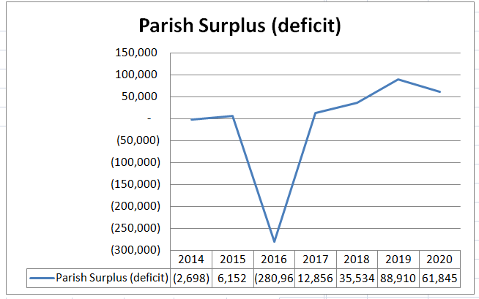
Parish Giving stays with the Parish

The Catholic Church is much more than our buildings – we are principally our people and the works of the Church. The Catholic Church is the nation’s largest non-government provider of pastoral care, primary and secondary schooling, tertiary education, healthcare, marriage preparation and counselling, social welfare services especially to the poor, aged care and palliative care. In some of these areas, the Catholic Church makes an even bigger contribution than any government in Australia. If the Church wasn’t doing our mission, who would?
Some examples of the vital works of the Catholic Church are:
- The Catholic Church is the largest non-government provider of health care services in Australia, including aged and community services.
- St Vincent’s Health Australia, for example, is the nation’s largest not-for-profit Catholic health and aged care provider. It is a clinical, research and education leader working in private hospitals, public hospitals and aged care services – for all people.
- The Catholic Church provides social and welfare services to more than a million Australians a year including more than 500 programs in the areas of disability, children and youth services, counselling, employment, parental assistance, refugees and assistance to the homeless.
- In education the current recurrent savings to NSW and Commonwealth Governments of not having to educate Catholic Systemic school students in state schools exceeds $483 million per annum.
- The Catholic Church has also built much of our country’s social infrastructure in these and other areas. It continues to build and sustain local communities of faith and service, and to support families and individuals where there is often little other support. It cares for the most disadvantaged and is a voice for the voiceless. It provides most of these things for our whole society, Catholics and non-Catholics alike.
But the Church can only do these good things for our community because generation after generation of Catholics have built up the infrastructure of churches, schools, convents, Vinnies centres and the rest that people call ‘Church assets’. Many ‘Church assets’ are in fact held on trust for specific purposes nominated by the government or benefactors who provided them (e.g. school grants, money earmarked for charitable works). Others are held to back employee entitlements, debts etc. Others again (like our cathedral) are artistic patrimony of the Church, city and nation. In all these cases the Church is not free to just dispose of the assets for any purpose and it is misleading to lump all these things together as “the wealth of the Church”.
Legacy and Bequest Giving
What we do with the gifts we have been given expresses what we believe. A legacy or a bequest is a gift left for the benefit of future generations. As good stewards, a Legacy program ensures that future needs of our Church and ministries are met. Our Christian faith, even in death, calls us to witness the new life that God gives in Christ through his death and resurrection.

A gift to the Parish Legacy Program may take many forms such as:
• Lump sum bequests or percentage of your estate as stated in your Will
• Beneficiary of Life Insurance, Superannuation or Tax Free Savings Account
• Gifts of cash or publicly traded shares during your lifetime
• Bequest of a specific asset such as real estate, jewellery or shares in your will.

Gifts may be made by individuals, families, organizations and/or corporations. These gifts may be directed to the general revenues of the Parish or to any specific ministry within the Parish such as:
• Debt reduction • Youth and Education • Music • Liturgy
• Adult Faith Formation • Evangelization • Outreach

By making a bequest to the Church, you can also elect to contribute to a specific important work of the Church, for example the Charitable Works Fund, The Priests Retirement Foundation, The Clerical Medical Fund of the Archdiocese of Sydney or the Clergy Remuneration System of the Archdiocese of Sydney.

For your final wishes to be honoured, you must have a valid Will. For this reason, it is very important that you arrange to have a valid Will drawn up by a solicitor. To learn more or discuss your Legacy Giving please contact the parish office.

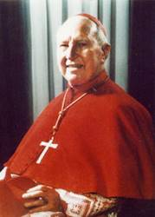
Cardinal Gilroy Society
The Cardinal Gilroy Society has been established to honour the generosity of those individuals who have pledged a bequest to any of the good works of the Sydney Archdiocese. The Society is a way that we can thank you now for your foresight and very special contribution.
The Society is named after Cardinal Norman Gilroy, Archbishop of Sydney from 1940 to 1971. Cardinal Gilroy made a significant contribution to Australian society and to the Catholic community. He was a veteran of Gallipoli, was ordained a priest in Rome, became the first Australian-born Cardinal and the first Cardinal since the reformation to receive a knighthood. In 1970 he was named Australian of the Year.
Members of The Cardinal Gilroy Society receive invitations to special events, a unique pin and a certificate. There is no cost or obligation for membership. If you are interested in joining, please contact the Bequest Manager of the Archdiocese of Sydney on 1800 753 959 or email bequests@sydneycatholic.org

To date, Saint Michael’s Parish has received generous Legacy Gifts in the last 10 years from our former now deceased parishioners.
Thank you to the following:
2006 - $241,943 – 50% of the Estate of Annie Irene Starkey
2017 - $5080 – Estate of Sespen Shidrawi
2018 – No Bequest this year.
2019 – No Bequest this year.
2020 – No Bequest this year.

Mortgage and Debt Reduction
The current balance of our parish debt is $0. Due to the incredible generosity of many generations of parishioners, the Parish is currently not in any debt. The Parish has very limited ability to generate additional income for future major works, and the small amount of annual income (approximately $24,000) generated from the parish savings ($1.486 million) means the Parish would find it difficult to undertake any new major developments without engaging loans. New pastoral initiatives or developments will require additional funding and will involve future loans for the parish.
In the early days of the Parish and until very recently (January 2017) the Parish has been responsible for a variety of loans, including loans for the building of the Church, the Bush Parish Hall, the building of the parish carpark, for the building and refurbishment of St Michael’s Meadowbank Primary School and so on. From 1 January 2017, the loan balance of $177,441 still owing for the Bush Parish Hall was transferred to St Michael’s Primary School as part of a restructure of the Parish Building Levies and the Parish School Building Funds.
Did You Know?
• Our parish electricity and utilities bills in 2020 for the church, presbytery and office was $7,905.
• Over 160 volunteers are serving in ministry and 138 tax receipts were issued for 2020 donations.
• 180 guests attended the Parish Volunteers Christmas party celebration on 21 December 2019.
• 25 baptisms occurred at St Michael’s in 2020, and 67 children made First Reconciliation and Confirmation on 2nd half of 2019. There was no First Holy Communion in June 2020 due to Covid19.
• There were 5 funerals and 4 weddings at St Michael’s in 2020.
• 365 children with 76% Catholics attended St Michael’s Meadowbank Primary School in 2020.
• Our pre covid Catechists have a combined 130 years of service.
• 250 children receive weekly classes in Catholic Scripture at the 3 Public Schools in the Parish (Meadowbank Public, West Ryde Public, Ermington Public).
• It costs approx. $700/year to supply donation envelopes to parishioners.
• In a typical month we use approximately 2,400 hosts at a cost of $50 each month.
• During a typical month, Pre Covid19 22 sick and homebound parishioners are visited and brought Holy Communion on a weekly basis.

Workplace Giving and Donation Matching
More and more Australian companies are undertaking employee matched giving programs. Close to 70% of companies in Australia now support employee fundraising efforts and/or workplace giving by matching the contribution.

What is workplace giving?
Workplace Giving is a joint relationship between employers, employees and registered charities. Individuals contribute a small portion of their pre-tax salary to a charity that offers a tax deduction. The individual will then receive the tax benefit straight away rather than waiting until the end of the financial year to submit a tax return. For example, if you donate $20, it will only cost you $12.60 (if you are on a high income) but the charity will receive the full $20. In most cases, employers will also match staff donations dollar for dollar, so the value of your donation will double to $40 direct to the charity of your choice.
If you don’t know if your employer will match your donations, then ask your Human Resources Department if your company has a matched giving program. If you work for a medium or large-sized company, then more than likely they will match your donations to charities, to special collections and to the Parish.
30% of regular Parish donations are eligible for tax deductions and 100% of Charitable Works Fund donations receive tax deductions. You and your employer could consider supporting the Charitable Works Fund or the Parish through matched giving.

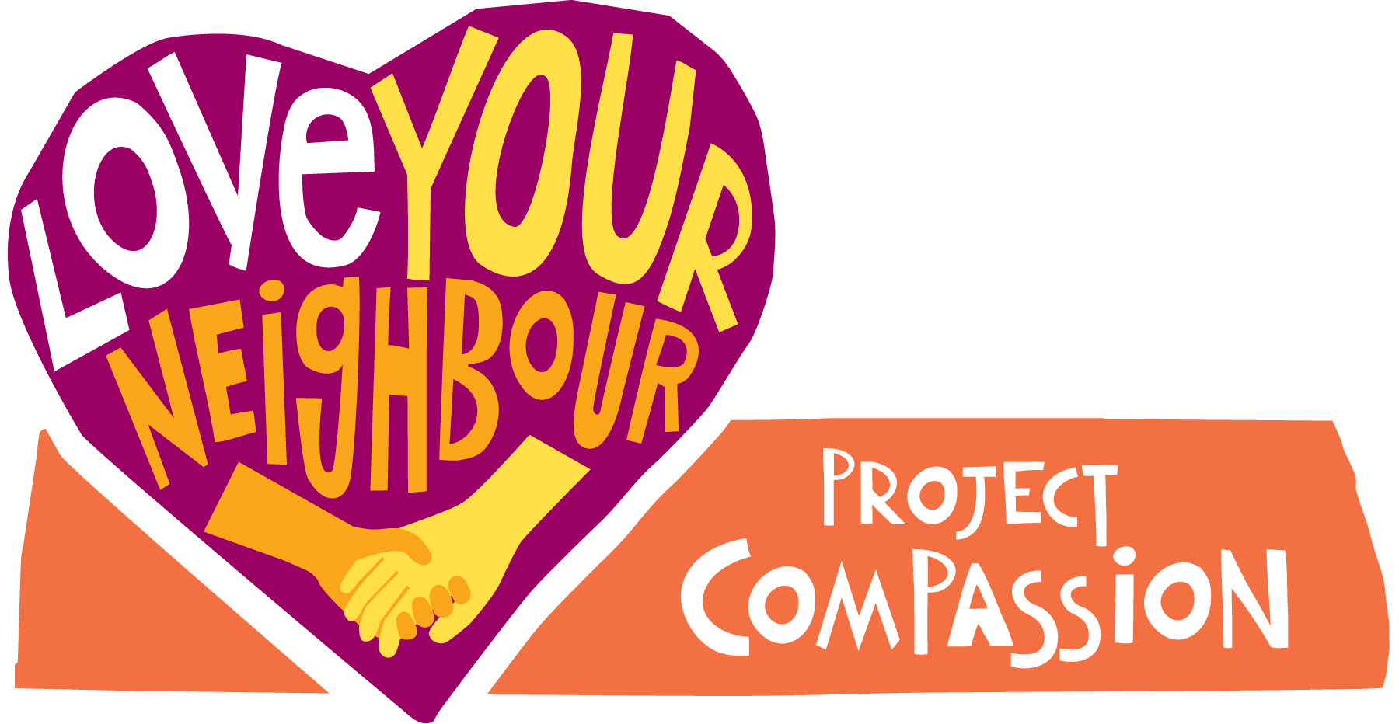
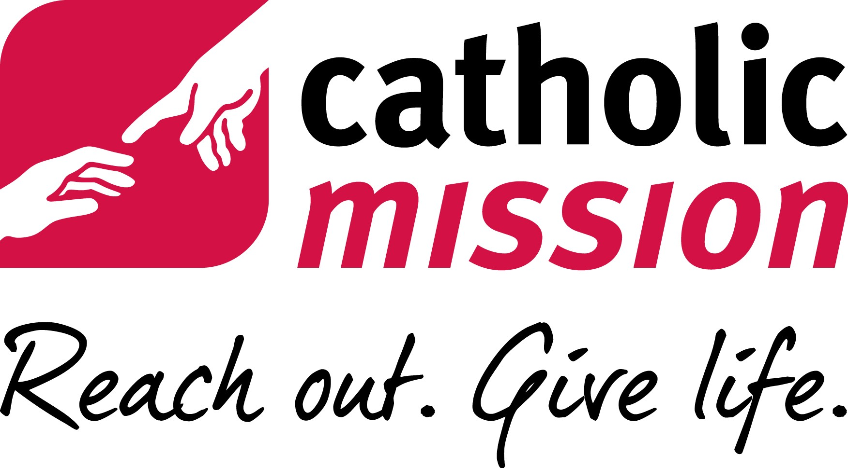
Special Collections
2015-2020

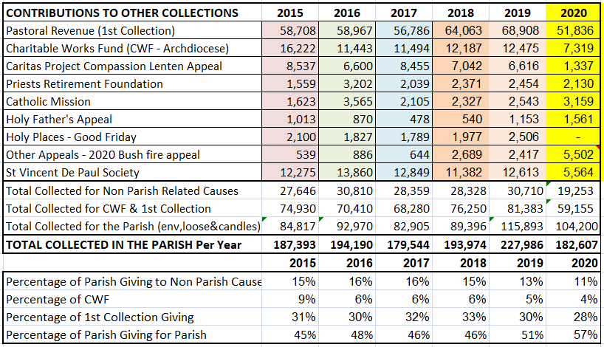

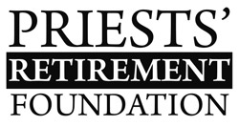
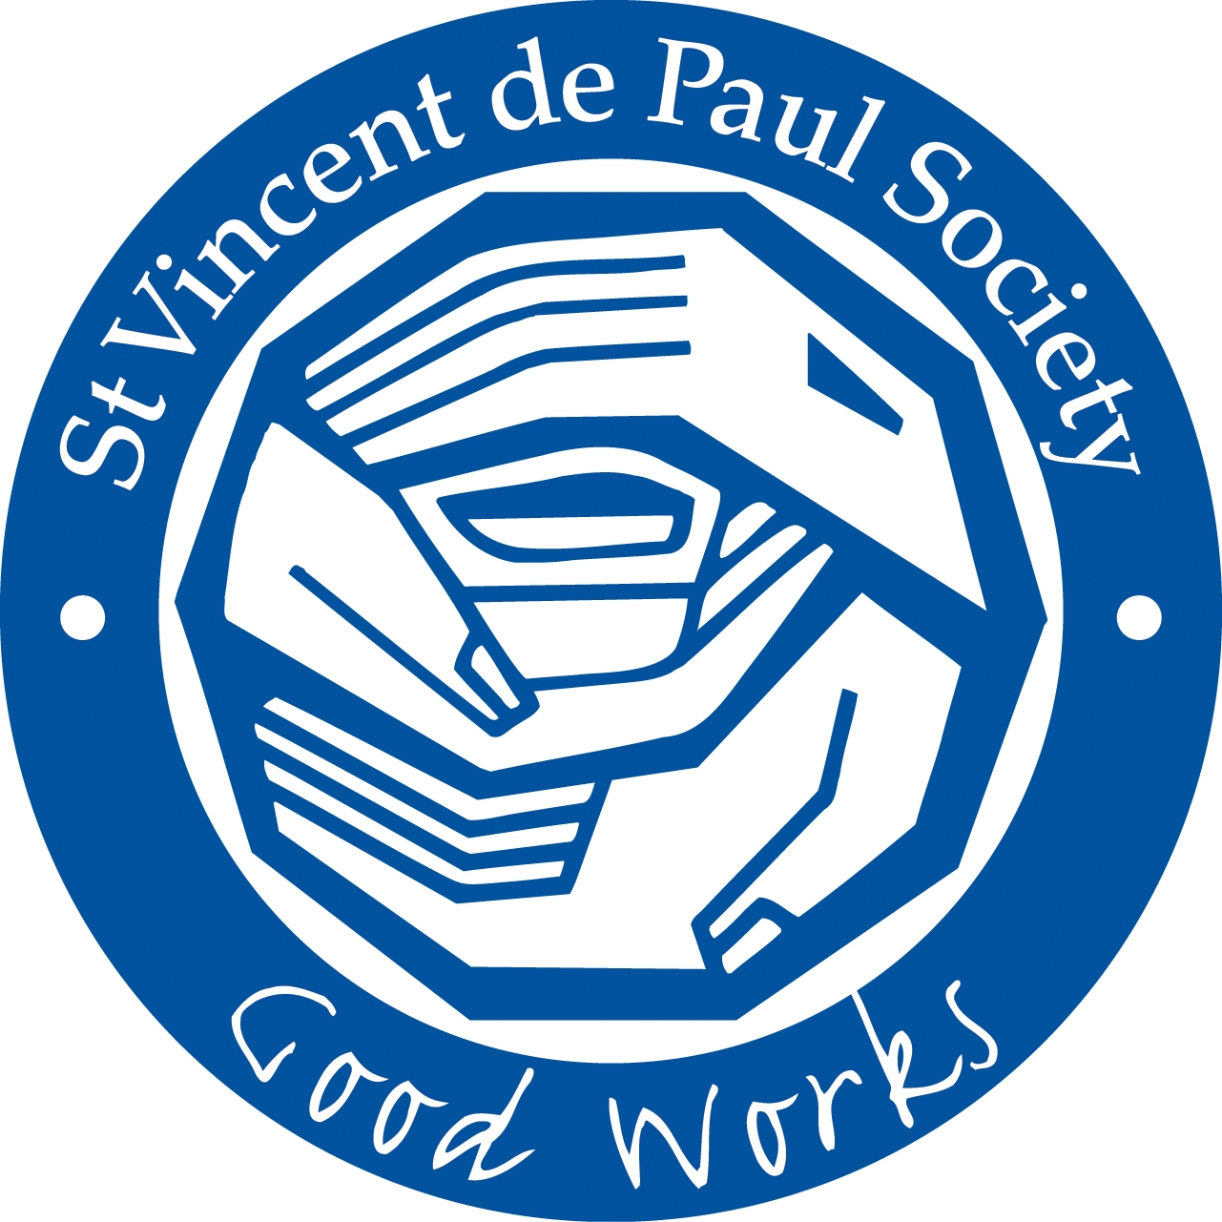
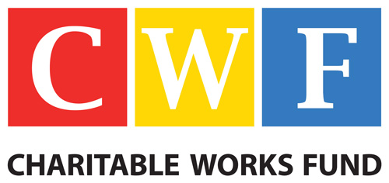

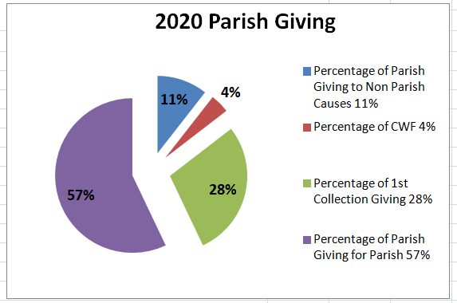

Archdiocesan Charitable Works Fund Appeal
Every year the Archdiocese of Sydney assesses parishes and determines an annual quota that each parish needs to raise for the Charitable Works Fund. The Charitable Works Fund (CWF) supports CatholicCare; CCD (ministry expenses for catechists in state schools); Ephpheta Centre for the Hearing Impaired; Aboriginal Catholic Ministry; and Seminaries, University and Hospital Chaplaincies. The CWF assists in furthering our mission of spreading the gospel of Jesus Christ to all corners of Sydney. The May 2020 appeal has been cancelled due to Covid19.

“Give, and it will be given to you.
A good measure, pressed down, shaken together, running over, will be put into your lap;
for the measure you give will be the measure you get back.” Luke 6:38

Financial information was based on Audited Parish Financial Reports – prepared by Rose Dearden

